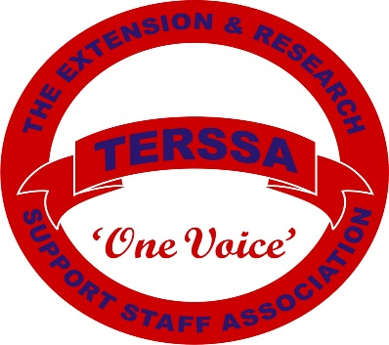
The Extension and Research Support Staff Association
Professional Development Scholarship
Guidelines
2023

- Must be a current, paid member of TERSSA for at least two (2) consecutive years.

- Deadline this year is August 15, 2023 with awards being given on October 19, 2023.

- Members of the Scholarship Committee are able to submit applications if they meet all criteria of these guidelines.

- The top two (2) applicants will each receive a $500 scholarship. Recognition of the recipients is during the Annual TERSSA National Meeting.

- The professional development event/class/meeting must be within one (1) year of notification of award. To receive reimbursement please provide the following: 1. Documentation and receipts showing enrollment, 2. Certificate, agenda, etc. showing completion, 3. Attached form for brief summary of how the event/class/meeting benefited you as a person and an employee.

- In the event a recipient does not follow these guidelines and does not complete the event/class/meeting of choice, the funds will go back into the TERSSA scholarship budget for the next year’s scholarship(s).

- Scholarships are for registration fees, books, travel, supplies and any incidentals pertaining to the event/class/meetings for the upcoming year. Receipts are required.

- Please submit your application to:
TERSSA Scholarship
Marianne Guthrie
3083 Ragged Ridge Road
Frankfort, OH 45628
or email: guthrie.76@osu.edu

- Any questions please contact Marianne Guthrie, guthrie.76@osu.edu
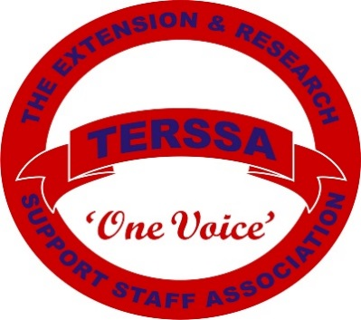
The Extension and Research Support Staff Association
Professional Development Scholarship
Application - 2023

Date Received ________________

Please mail or email application to: TERSSA Scholarship, Marianne Guthrie, 3083 Ragged Ridge Road, Frankfort, OH 45628. Email: guthrie.76@osu.edu. Must be received by August 15, 2023

Number of consecutive years in TERSSA _______

Name: _______________________________ Job Title: _____________________________________

Address: ____________________________________________________________________________
Street City State Zip

Work Location: ______________________________________________________________________

Please provide a brief description of your current position: (Use space available, additional pages are not considered.)

Please provide a brief statement describing the professional development that you will attend, the advantages of attending the event, class, meeting etc. AND how it will benefit you personally and in your job duties. (Use space available, additional pages are not considered.)

________________________________________ __________________________________
Signature Date

The 2023 scholarship recipient(s) will submit this form at the conclusion of their event/class/meeting accompanied by the request for reimbursement.

Please provide a brief statement describing the advantages of attending the event, class, meeting etc. and how it benefited you personally and in your job duties. (Use space available, additional pages are not considered.)

Please submit your receipts with an expense reimbursement form (found on the TERSSA.org page https://www.terssa.org/page-7745) and this form to: Marianne Guthrie, 3083 Ragged Ridge Road, Frankfort, OH 45628, Email guthrie.76@osu.edu

